Risk Assessment Guidance
Risk Management:
The requirement is to manage risk. The risk assessment process is one tool used to manage risk. It involves the identification of hazards, an understanding of who may be harmed by the hazard, an estimate of both the likelihood of it happening and also the consequence i.e. the severity of the outcome. Once this assessment has been made then controls are identified and put in place in an attempt to prevent or reduce either the likelihood, the consequence or both. Putting the controls in place and making sure they are maintained is the management of risk.
Legal Requirement:
It is a legal requirement for every employer and self-employed person to make an assessment of the health and safety risks arising out of their work. The purpose of the assessment is to identify what needs to be done to control health and safety risks. Regulation 3 of the Management of Health and Safety at Work Regulations 1999 states:

Risk assessment
3. (1) every employer shall make a suitable and sufficient assessment of:
(a) the risks to the health and safety of his employees to which they are exposed whilst they are at work; and
(b) the risks to the health and safety of persons not in his employment arising out of or in connection with the conduct by him of his undertaking
Hierarchy of Controls:
Risks should be reduced to the lowest reasonably practicable level by taking preventative measures, in order of priority. This is what is meant by a hierarchy of control. The list below sets out the order to follow when planning to reduce risks you have identified in your workplace. Consider the headings in the order shown, do not simply jump to the easiest control measure to implement.
- Elimination - Redesign the job or substitute a substance so that the hazard is removed or eliminated.
- Substitution - Replace the material or process with a less hazardous one.
- Engineering controls - for example use work equipment or other measures to prevent falls where you cannot avoid working at height, install or use additional machinery to control risks from dust or fume or separate the hazard from operators by methods such as enclosing or guarding dangerous items of machinery/equipment. Give priority to measures which protect collectively over individual measures.
- Administrative Controls - These are all about identifying and implementing the procedures you need to work safely. For example: reducing the time workers are exposed to hazards (eg by job rotation); prohibiting use of mobile phones in hazardous areas; increasing safety signage, and performing risk assessments.
- Personal protective clothes and equipment - Only after all the previous measures have been tried and found ineffective in controlling risks to a reasonably practicable level, must personal protective equipment (PPE) be used. For example, where you cannot eliminate the risk of a fall, use work equipment or other measures to minimise the distance and consequences of a fall (should one occur). If chosen, PPE should be selected and fitted by the person who uses it. Workers must be trained in the function and limitation of each item of PPE.

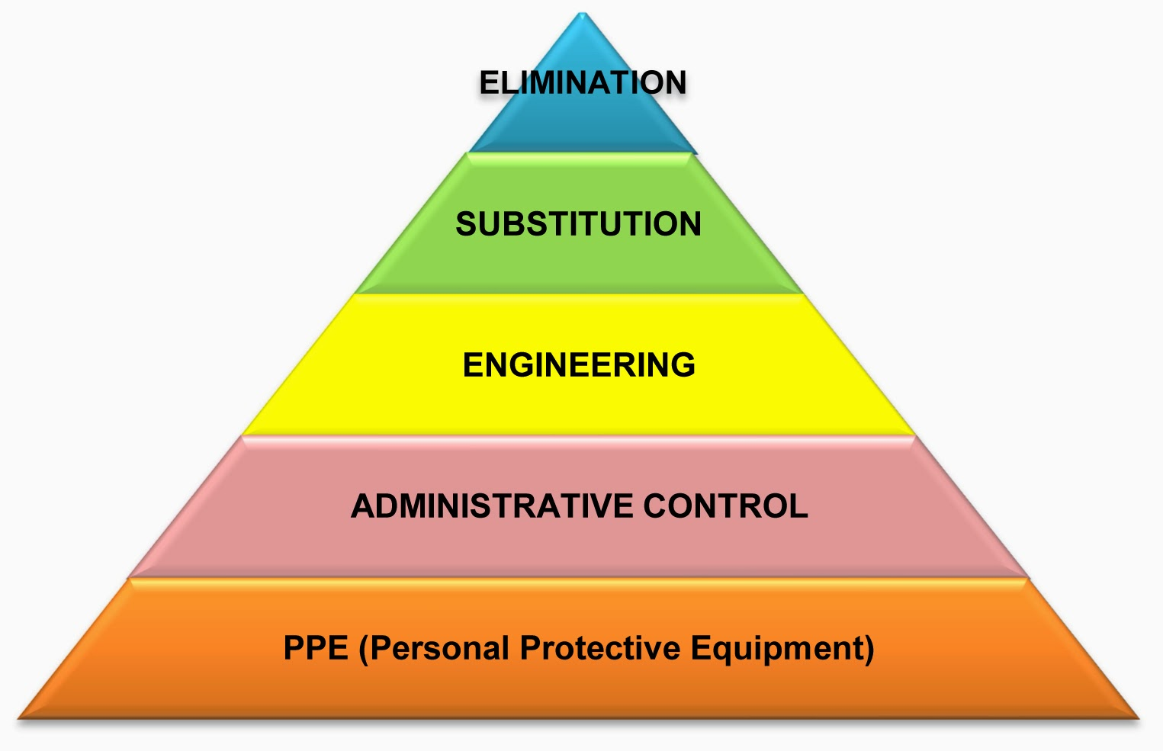
Fire:
As an employer (and/or building owner or occupier) you are required to carry out and maintain a fire safety risk assessment. This is under the Regulatory Reform (Fire Safety) Order 2005, which applies in England and Wales, and under Part 3 of the Fire (Scotland) Act. The fire safety assessment can be carried out either as a separate exercise or as part of a single risk assessment covering other health and safety risks.
You need to make sure that, based on the findings of the assessment, you take adequate and appropriate fire safety measures to minimise the risk of injury or loss of life in the event of a fire.
Who is responsible?
As an employer or a self-employed person, you are responsible for health and safety in your business.
You can delegate the task, but ultimately you are responsible. You will need to make sure that whoever does the risk assessment:
- is competent to do so
- involves your workers in the process
- understands when specialist help might be needed
Do I need to use a consultant?
- No. In most cases, you can do the assessment yourself with the help of your staff.
- You may need extra help or advice if you do not have sufficient experience or knowledge in-house. You may also need extra help if the risks are complex
Who do I involve?
You must consult your staff or their representatives in the risk assessment process. They will have useful information about how work is done which will help you understand the actual risks.
How do I prioritise controls?
You may find that there are a number of issues which need action, so you need decide on your priorities for that action. In thinking through your priorities, think about the biggest or most serious risks first.

Having identified the priorities, you need to decide on the controls which you will put into place. In doing so, think about the following:
- long-term solutions to those risks with the worst potential consequences
- long-term solutions to those risks most likely to cause accidents or ill health
- whether there are improvements that can be implemented quickly, even as a temporary solution until more reliable controls are in place
Remember, the greater the risk the more robust and reliable the control measures will need to be.
When should I review my risk assessments?
You should review your risk assessment:
- if it is no longer valid
- if there has been a significant change
Your workplace will change over time. You are likely to bring in new equipment, substances and procedures. There may be advances in technology. You may have an accident or a case of ill health. You should review your assessment if any of these events happen.
Remember to amend your assessment as a result of your review.
There is no set frequency for carrying out a review.
Do I need to sign my risk assessments?
No. There is no legal requirement for you to sign your risk assessment. Bear in mind however, as previously stated you are responsible for health and safety in your business.
What responsibilities do my employees have?
Employees also have responsibilities under health and safety law to:
- take care of the health and safety of themselves and others
- co-operate with you to help you comply with health and safety legislation
- follow any instructions and training you give regarding the measures you have in place to control health and safety risks
- let you know of work situations that present a serious and imminent risk
- let you know of any other failings they identify in your health and safety arrangements
What if the work I do varies a lot, or moves from one site to another?
Assess the risks you can reasonably expect to find. When you take on work or go to a new site, cover any new or different risks with a specific assessment.
Terminology:
What is a hazard?
A hazard is anything that may cause harm, eg chemicals, electricity, working from ladders, noise etc.
What is risk?
Risk is the chance (likelihood), high or low, of somebody being harmed by the hazard, and how serious the harm could be (consequence).
What is a risk matrix?
Most businesses will not need to use risk matrices. However, they can be used to help you work out the level of risk associated with a particular issue. They do this by categorising the likelihood of harm and the potential severity or consequence of the harm. This is then plotted in a matrix (please see below for an example). The risk level determines which risks should be tackled first.
Using a matrix can be helpful for prioritising your actions to control a risk. It is suitable for many assessments but in particular to more complex situations. However, it does require expertise and experience to judge the likelihood of harm accurately. Getting this wrong could result in applying unnecessary control measures or failing to apply sufficient ones.
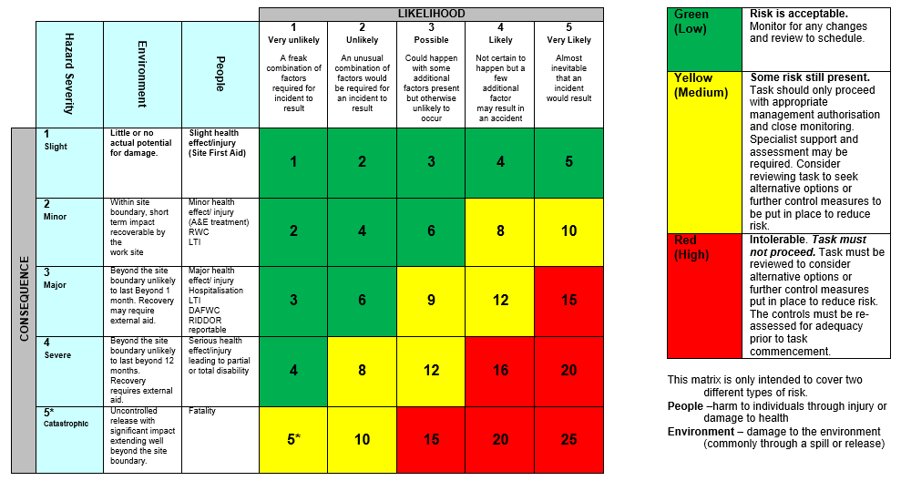
What is the difference between a risk assessment and a method statement?
A risk assessment is simply a careful examination of what, in your work, could cause harm to people, so that you can weigh up whether you have enough precautions or whether you should do more.
As an employer or self-employed person, you must do a risk assessment but you only need to record it if you employee five or more people.
A safety method statement is not required by law. It describes in a logical sequence exactly how a job is to be carried out in a safe manner and without risks to health. It includes all the risks identified in the risk assessment and the measures needed to control those risks. This allows the job to be properly planned and resourced.
Safety method statements are most often found in the construction sector. They are particularly helpful for:
- higher-risk, complex or unusual work (eg steel and formwork erection, demolition or the use of hazardous substances)
- providing information to employees about how the work should be done and the precautions to be taken
- providing the principal contractor with information to develop the health and safety plan for the construction phase of a project
Whether safety method statements are used or not, it is essential to make sure that risks are controlled.
Significant Risks:
Significant risks are those that are not trivial in nature and are capable of creating a real risk to health and safety which any reasonable person would appreciate and would take steps to guard against.
Reasonably Practicable:
This means balancing the level of risk against the measures needed to control the real risk in terms of money, time or trouble. However, you do not need to take action if it would be grossly disproportionate to the level of risk. The term used is ‘…to reduce risk to As Low As Reasonably Practicable’ (ALARP)

